Biology, Castle View High School
Jason R Mayberry, PhD
Study Guide: Lipids and Carbohydrates
Vocabulary
- Lipid
- Triglyceride
- Phospholipid
- Steroids
- Cholesterol
- Amphipathic
- Phospholipid Bilayer
- Organic Soup (also called Primordial Soup)
- Protocell
- Carbohydrates
- Monosaccharide
- Disaccharide
- Polysaccharide
- Glycogen
- Starch
- Cellulose
- Photosynthesis
- Cellular Respiration
- Glycoprotein
- Glycolipid
Conceptual Questions
- Draw the basic/simplified structure of a triglyceride? What is made of triglycerides?

- Draw the basic/simplified structure of a phospholipid. What is made of phospholipids?

- Be able to recognize a cholesterol molecule (or any of its steroid derivatives such as testosterone and estrogen).
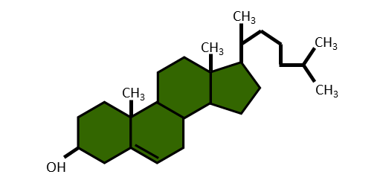
- Describe how the properties of a phospholipid make it good for forming membranes.

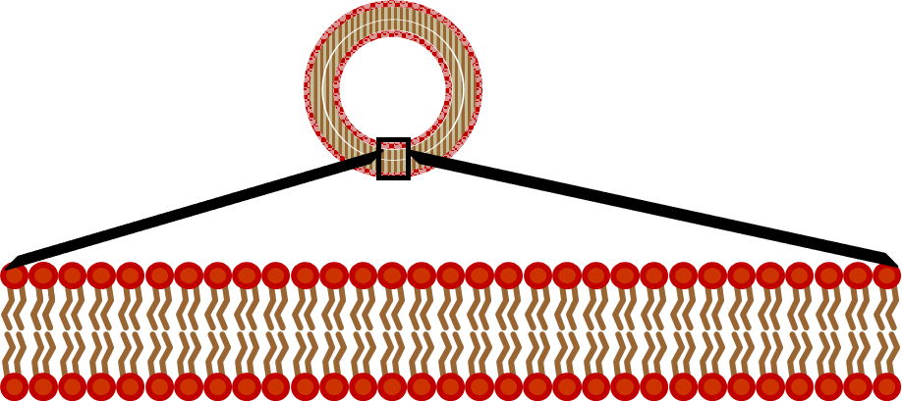

- Describe the structure and composition of cellular membranes.

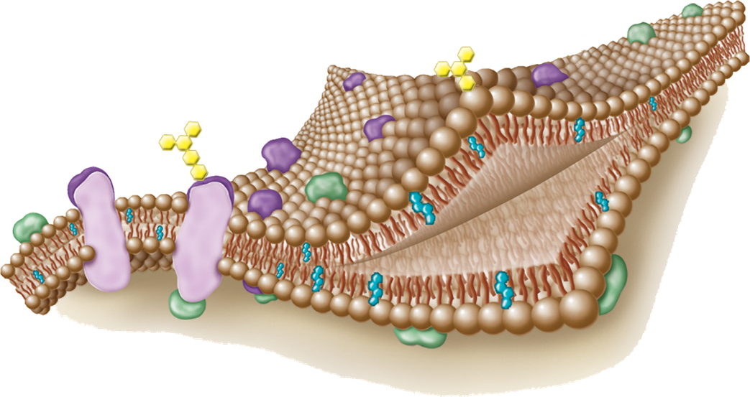
- How did the first cells form out of the Organic Soup (also called Primordial Soup)?

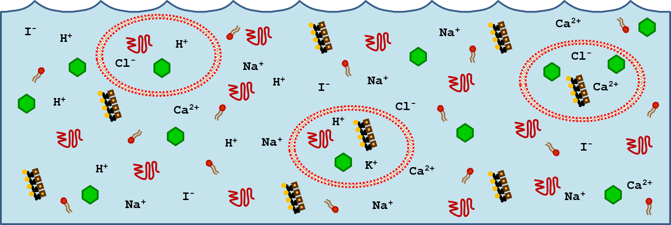

- Give examples of the processes that arose from the interactions of organic molecules captured in the first protocells.
- Describe why the term “Carbohydrate” is an appropriate term to describe the molecules given this name.

- Draw a monosaccharide. What feature gives this away as a carbohydrate?

- Draw a simplified Disaccharide

- Draw a simplified polysaccharide.

- Contrast the uses of Glycogen, Starch, and Cellulose.

- Briefly describe how carbohydrates are made.
- Briefly describe some key uses of carbohydrates.
